

**Table of Contents**

**Executive Summary 3**

**1.1 Mission 5**

**1.2 Objectives 5**

**2.1 Company Ownership 5**

**2.2 Company Description 6**

**2.3 Products and Services 7**

**2.4 Company Strategic Location 7**

**3.1** **Investment Summary** **8**

**4.1 Market Analysis Summary 8**

**4.2 Market Segmentation 9**

**5.1 Competition 10**

**5.2 Competitive Advantages**   **11**

**6.1 Marketing Program 1**4

**6.2 Sales Strategy 1****5**

**6.3 Company’s Contribution to the U.S. Economy 1****6**

**7.1 Organizational Chart 1****7**

**7.2 Personnel** **Plan**   **18**

**7.3 J****ob Description - Beneficiary** **20**

**8. Financial Plan** **21**

**8.1 Revenue Forecast** **22**

**8.2 Projected Profit and Loss** **22**

**8.3 Five-Year Forecast of Investor Income** **23**

# 

# **Executive Summary**

Pilaform LLC, founded on January 3, 2024, under the laws of the State of Delaware, aims to become a cornerstone in the Jupiter, Florida Pilates industry. With **Elizabeth Bartley**, a Canadian national holding 95% ownership, and **Howard Goldman**, also Canadian national, holding 5%, Pilaform is set to own and operate a Pilates studio committed to fostering a community for personal growth and self-discovery.

Offering a diverse range of group and private classes six days a week along with wellness products, Pilaform will target both local residents and visitors. With a focus on the female demographic, marketing strategies include maintaining a professional website, advertising on social media such as Facebook, Linkedin, Instagram, and TikTok and collaborations with local businesses and health practitioners.

Additionally, Pilaform will purchase advertising through the Mindbody app, place advertisements with local magazines and websites, and claim its Yelp listing. The Company will also establish strategic partnerships with local health practitioners' businesses, including hotels, traditional Chinese medicine (TCM) providers, massage therapists, and chiropractors. Engaging with the local community through donations, connecting with local businesses, and hosting events is also a priority. Pilaform will further distribute informative brochures to local residents, coffee shops, hair salons, and farmer’s markets, while also participating in industry events.

As the Pilates and yoga studios industry anticipates continued growth, with revenue projections reaching $11.8 billion by 20231 and an expected CAGR of 11.50% by 2032[1], Pilaform is primed for success.

To date, Ms. Bartley has spent $99,419.28 to support the Company’s establishment and growth. Ms. Bartley plans to make an additional capital infusion of approximately $70,000 into the Company, for a total investment of $169,419.28. Pilaform will purchase Pilates equipment, booking software, a washer/dryer, and Pilates supplies from U.S.-based suppliers, thereby creating direct and indirect jobs in the United States through contractors and suppliers.

Once an E-2 nonimmigrant visa is approved for Ms. Bartley, she will occupy the position of CEO and President. Ms. Bartley has eight (8) years of professional experience.

By the end of Year 1, the Company’s team will comprise five positions, including two independent contractors. By the end of Year 5, Pilaform plans to increase its staff to eight positions, including three independent contractors. Revenue projections stand at $385,600 by the end of Year 1 and $679,641 by the end of Year 5.

Looking ahead, Pilaform will explore opportunities such as offering online Pilates workout content, opening additional locations in South Florida and potentially franchising.

**1.1 Mission**

Pilaform’s mission will be to empower individuals to achieve optimal physical and mental well-being through the Pilates method. The Company will seek to cultivate a strong mind-body connection and a nurturing and inclusive environment where clients of all ages and fitness levels can discover the transformative power of Pilates.

# **1.2 Objectives**

The Company has identified the following objectives that will underpin its future success:

* Hire and continually train qualified certified staff members who can modify sessions to ensure all clients are accommodated and have a positive experience.
* Establish a marketing strategy that promotes the Company in its local service area through online and print advertising.
* Consistently develop the Company’s variety of classes to ensure that the lessons being offered are in line with clients’ interests.
* Create a positive atmosphere that helps clients feel their very best and cultivate customer loyalty and referrals.
* Invest in high-end renovations and maintain an updated modern space.
* Consider offering online Pilates workout content, opening additional locations in South Florida, and potentially franchising in the future.
* Achieve revenues of US $385,600 by the end of Year 1 and US $679,641 by the end of Year 5.

# **2.1 Company Ownership**

Pilaform LLC was formed on January 3, 2024, under the laws of the State of Delaware. The Company has two (2) shareholders:

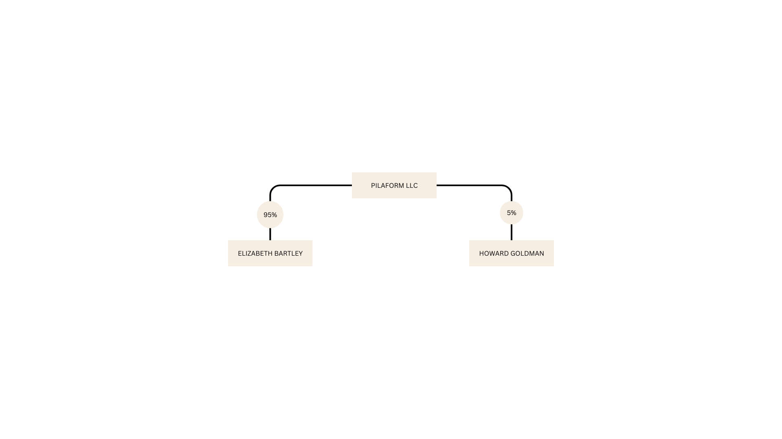

# **2.2 Company Description**

Pilaform will own and operate a Pilates studio located in Jupiter, Florida, aiming to foster a community for personal growth and self-discovery. The studio will offer Pilates group apparatus classes, 1-on-1 private sessions, and group barre fitness classes. Additionally, products related to Pilates and wellness will be available. Operating hours will be from 7 a.m. to 8 p.m. Sunday through Friday.

Pilates, developed by Joseph Pilates in the early 1900s, focuses on improving strength, flexibility, balance, and posture.[2] The method emphasizes concentration, flow, precise movement patterns, and controlled breathing. Joseph Pilates designed over 600 exercises and apparatus to condition the entire body, correct body alignment, and balance.[3] Pilaform aims to establish a safe environment providing contemporary Pilates classes for people of all ages and abilities. The instructors, predominantly Body Arts and Science International (BASI)-certified, will offer preparatory exercises and modifications to suit every student's needs.[4]

Pilaform will differentiate itself through its modern, renovated space and personalized services compared to franchises. Future plans include offering online Pilates content, expanding to additional locations in South Florida, and potentially franchising.

In the future, the Company will consider offering online Pilates workout content, opening additional locations in South Florida, and potentially franchising.

# **2.3 Products and Services**

Pilaform will initially offer classes in the following packages:

* **Private Pilates sessions**: Individually tailored sessions designed to address specific goals and needs, providing personalized attention and instruction for optimal results.
* **Group Apparatus classes**: Engaging and dynamic classes conducted on specialized Pilates apparatus, offering a comprehensive workout experience that targets strength, flexibility, and balance.
* **Group mat and barre classes**: Energizing and invigorating classes conducted on the mat and utilizing barre techniques, focusing on core strength, alignment, and overall conditioning in a supportive group setting.
* **Virtual private sessions**: convenient and accessible one-on-one sessions conducted virtually, allowing clients to enjoy personalized instruction and guidance from the comfort of their own homes.
* **Virtual group classes**: Interactive and engaging group sessions conducted virtually, providing clients with the flexibility to participate in live classes from any location while still experiencing the camaraderie and motivation of a group setting.

Additionally, Pilaform will offer a variety of products and services to enrich the Pilates experience and foster overall well-being. These include Pilates equipment, accessories, nutritional supplements, and other wellness products, all aimed at supporting the holistic needs of our clientele.

In the future, plans entail providing online Pilates workout content for convenient access to instructional videos and resources. Moreover, we aim to explore growth opportunities by expanding our presence with additional locations in South Florida and potentially franchising our concept to broaden our influence within the wellness community.

# **2.4 Company Strategic Location**

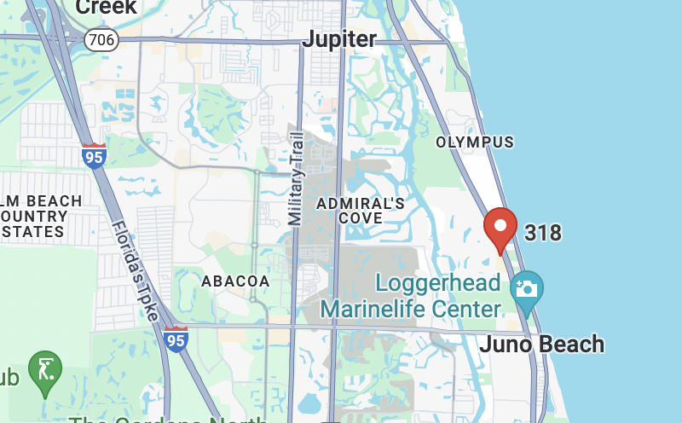

On January 26, 2024, Pilaform took a significant step by finalizing a 3-year lease agreement with Northern-Collins Corporation (Lessor) to secure a 1,006 square-foot commercial space at **4050-4302 US Highway 1, Suite No. 318 Jupiter, FL 33477**, known as the “Bluffs Square Shoppes”. This strategic location places Pilaform at the heart of the Treasure coast, offering convenient access to the thriving community of over 33,000 residents with an impressive average household income of $164,029[5]. This demographic aligns perfectly with the target clientele for Pilates, as demonstrated by the findings of the Pilates in America study, which indicates that 50% of Pilates clients have an average household income exceeding $100,000.[6]

Moreover, the presence of major tenants and national retailers in the shopping center, such as Publix, TooJay’s Restaurant, UPS, and Walgreens, provides Pilaform with invaluable networking opportunities and the potential to attract numerous clients. The advantageous traffic flow along US-Highway 1 ensures heightened visibility and accessibility, providing a clear competitive advantage.

# **3.1 Investment Summary**

Ms. Bartley is investing US$169,419.28 to establish and grow the Company. The table below shows the breakdown of the initial investment, categorized by cost types:

| **TOTAL INITIAL INVESTMENT** |  |
| --- | --- |
|  |  |
| **Committed** | $99,419.28 |
| **Future** | $70,000 |
|  |  |
| **TOTAL** | **$169,419.28** |

Of the total US$169,419.28 investment, Ms. Bartley already committed $99,419.28 in equipment, rent, legal fees, marketing expenses, certifications and company formation. See below a breakdown of the committed funds below:

| **COMMITTED FUNDS CATEGORY BREAKDOWN** |  |  |
| --- | --- | --- |
|  |  |  |
|  | **Item cost** | **Total** |
| **Equipment** |  | **$65,924.31** |
| Balanced Body Equipment | $47,092.81 |  |
| Basi Systems Equipment | $18,831.50 |  |
|  |  |  |
| **Rent** |  | **$18,667** |
|  |  |  |
| **Legal Fees** |  | **$12,266** |
| Attorney Fees | $10,000 |  |
| Business Plan | $1,648 |  |
| Business Plan 2nd payment | $618 |  |
|  |  |  |
| **Marketing** |  | **$1,068.97** |
| Marketing website GoDaddy | $30.34 |  |
| Marketing website GoDaddy | $27.06 |  |
| Website brand/design + social media | $700 |  |
| Business Cards | $119.57 |  |
| Squarespace | $192 |  |
|  |  |  |
| **Certifications** |  | **$1,020** |
|  |  |  |
| **Company Formation** |  | **$473** |
| Company Formation | $313 |  |
| New LLC | $160 |  |
|  |  |  |
| **TOTAL** |  | **$99,419.28** |

Moving forward, Ms. Bartley plans to invest the remainder of the start-up funds on studio renovations, additional Pilates accessories, and MindBody services subscription.

| **COMMITTED FUNDS CATEGORY BREAKDOWN** |  |  |
| --- | --- | --- |
|  |  |  |
|  | **Item cost** | **Total** |
| **Pilates Accessories** |  | **$5,000** |
| Mats | 1,407 |  |
| 9'' Balls | 150 |  |
| Small Hand Weights | 1,100 |  |
| Foam Rollers | 1,159.80 |  |
| Misc. |  |  |
| **Mind Body Service (annual)** |  | **$3,348** |
| Monthly Fee | $279 |  |
|  |  |  |
| **Renovations** |  | **$61,645** |
| Gary Meade for renovation management and labour | $34,195 |  |
| New Bathroom Fixtures | $2,000 |  |
| Water Filtration System | $1,000 |  |
| Washer/Dryer | $1,450 |  |
| Signage | $3,000 |  |
| Ceiling Renovation (HVACC, Sprinkler, electrical) | $15,000 |  |
| Mirrors & Barres and installation | $3,500 |  |
| Mini fridge, planters, sofa/bench, artwork | $1,500 |  |
|  |  |  |
| **TOTAL** |  | **$69,993** |

# **4.1 Market Analysis Summary**

Pilates and yoga studios' revenue swelled until COVID-19, which halted this industry's expansion trajectory. Despite strengthening participation in Yoga and Pilates, the closures due to mandated closures stifled studio attendance in 2020. Still, revenue is estimated to reach $11.8 billion over the five years to 2023, when revenue dipped 1.4%.[7] Over the eight years to 2032, Pilates and Yoga Studio revenue is expected to increase at a CAGR of 11.50%. 7

Despite downward trends as a result of the COVID-19 pandemic, the number of businesses in the gym, health, and fitness clubs industry in the U.S. has grown 2.3% per year on average over the five years between 2018 and 2023. Florida contains the second largest number of gyms, health, and fitness clubs industry establishments at 8,637 businesses.8

Over the next five years, Pilates and yoga studios will continue recovering from pandemic drops. Studios with sufficient means will incorporate digital and hybrid options, including online and combined yoga and Pilates classes. [8] Over the eight years to 2032, Pilates and Yoga Studio revenue is expected to increase at a CAGR of 11.50%. 9

As per data provided from the Mindbody App; the West Palm Beach area consumers book over 1,203,109 classes and appointments each month via Mindbody. Each month, on average 293 consumers use Mindbody to book a class or service they have never tried before. 10

# **4.2 Market Segmentation**

The Pilates industry, as per the Company’s research, is segmented as follows:

**Consumers aged 18 to 29**

This segment includes consumers between the ages of 18 and 29 who attend yoga or Pilates classes. Constraints on disposable income prevent more people in this demographic from attending yoga and Pilates classes. [9]

**Customers aged 30 to 49**

This segment includes consumers aged 30 to 49 who attend yoga or Pilates classes. Practitioners in this age group generate the most sales for Pilates and yoga studios since they have more disposable income than their younger counterparts. Health-consciousness trends have flourished among this age group, and studios have appealed to this market accordingly.[10]

**Consumers aged 50 and older**

This segment includes consumers aged 50 and older who attend yoga or Pilates classes which makes up 41% of Pilates clients. 13

# **5.1 Competition**

The Company has identified the following competitors operating in the Pilates studio industry.

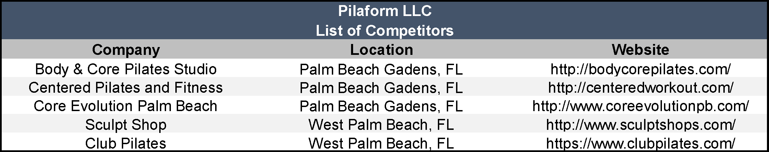

**Centered Pilates and Fitness** [<https://www.centeredworkout.com/>]

Centered Pilates and Fitness is a fitness studio located in North Palm Beach, Florida. The studio specializes in Pilates, TRX, and more. All fitness abilities and goals are welcome. The studio's mission is to help people find their center as they strengthen their core.

**Core Evolution Palm Beach** [<https://coreevolutionpb.com/>]

Core Evolution Palm Beach is a fitness studio in Northern Palm Beach County, Florida, which offers the exclusive Megaformer machine and the Lagree Fitness Method.[11] This method emphasizes both strength training and cardio elements while maintaining a safe, low-impact environment for joints, muscles, and ligaments. Core Evolution Palm Beach is the only studio in the area that offers this workout.

**Sculpt Shop [**<https://www.sculptshops.com/>]

Sculpt Shop is a Pilates and High-Intensity, Low-Impact Training (HILT) studio with locations in Jupiter and West Palm Beach, Florida. The studio offers uncompromising fitness results, prioritizing your body's long-term well-being with workouts tailored to challenge without causing unnecessary wear and tear. Sculpt Shop workouts are designed to be time-efficient, allowing you to get the most out of your workout in just 50 minutes. The studio also offers a unique HITT interval program that emphasizes functional movements and diverse equipment for a dynamic workout experience.

**5.2 Competitive Advantages**

Pilaform is poised for success based on several key factors that sets the Company apart within the industry:

|  | **Pilaform Pilates** | Body & Core  Pilates | Centered Pilates and Fitness | Core Evolution | Sculpt Shop |
| --- | --- | --- | --- | --- | --- |
| **Services** | -Group equipment classes  -Private sessions  -Barre classes  -Mat Pilates classes  -Yoga group and private  -Prenatal and Postnatal group classes | -Group Pilates classes on reformer  -Private sessions  -Redcord Suspension  -CoreAlign Sessions | -Group Pilates classes on equipment  -TRX  -Private sessions | -Lagree studio that focuses on Lagree group classes on Megaformers | -Lagree studio advertising as Pilates. Focus on group classes on Megaformers |
| **Client Demographic** | All ages, with a focus on the 18-50 year old demographic | All ages with a focus on 50+ | All ages with a focus on 50+ | 18-50 | 18-50 |
| **Marketing Presence** | Website, Instagram,  Tik Tok,  Facebook,  LinkedIn,  Print Advertising | Website, Instagram, Facebook,  Print Advertising | Website,  Instagram,  Facebook | Website, Instagram,  Facebook | Website,  Instagram,  Facebook |
| **Location Coverage** | Jupiter,  Juno Beach,  Palm Beach Gardens,  West Palm Beach | Jupiter,  Juno Beach,  Palm Beach Gardens,  West Palm Beach | Jupiter,  Juno Beach,  Palm Beach Gardens,  West Palm Beach | Jupiter,  Juno Beach,  Palm Beach Gardens | Jupiter,  Juno Beach,  Palm Beach Gardens,  West Palm Beach |
| **COMPETITIVE ADVANTAGES** | | | | | | |
| Elizabeth’s Credentials | **✔** |  |  |  |  |
| Marketing and online presence | **✔** |  |  | **✔** | **✔** |
| High-end experience | **✔** |  |  |  |  |
| Well renovated studio | **✔** |  |  | **✔** |  |
| Offers Pilates services | **✔** | **✔** | **✔** |  |  |
| Class sizes and quality of instruction | **✔** | **✔** | **✔** |  |  |
| Equipment quality | **✔** |  |  | **✔** | **✔** |
| Private personalized sessions | **✔** | **✔** | **✔** |  |  |
| Variety of services | **✔** |  |  |  |  |
| Affordable group classes | **✔** |  |  | **✔** | **✔** |
| 18-50 year old demographic | **✔** |  |  | **✔** | **✔** |

**Ms. Bartley’s Credentials**

Pilaform gains a competitive edge through the exceptional leadership of Elizabeth Bartley and assistance from the company's secretary, Howard Goldman. With over five decades of combined entrepreneurial, managerial, and marketing expertise, Pilaform brings a unique perspective to the Pilates and fitness industry. Ms. Bartley, with her successful ventures in marketing, event management, fitness, and Pilates, possesses a diverse background that equips her with invaluable insights into consumer psychology and the art of creating exceptional customer experiences.

One of Ms. Bartley’s notable strengths is her exceptional client acquisition abilities, honed through years of experience in industries where understanding and meeting customer needs are paramount. Her insights into marketing services enable the company to establish a strong brand presence, maximize reach, and boost profitability. Her in-depth understanding of fitness, Pilates, anatomy, and movement combined with her high aptitude for interpersonal skills provides further competitive advantage within the industry. Her leadership ensures effective operations, sound financial management, strong client relationships, and strategic growth planning—essential elements for success in the Pilates and yoga industry.

Ms. Bartley’s credentials and extensive experience provide Pilaform with a distinct competitive advantage, setting it apart from other Pilates and Lagree companies in the industry. Her unique insights into consumer behavior, effective client acquisition abilities, and track record of successful business management position the company for growth and success in a highly competitive market.

**Renovated Space and High-end Experience**

Pilaform Pilates will invest a substantial amount of investment into the renovation of the space. Providing clients with a high-end experience in a renovated space improves client retention rates, revenue, and an improved brand image. A current trend on social media is for clients to film their experience at Pilates studios, including recording their workouts and posting photos taken in studio mirrors. A well-renovated space that offers a superior experience improves brand image. A strong online brand image lends itself to the company's long-term goal of opening multiple locations in South Florida.

**Service Offerings**

Pilaform Pilates stands out in the current market by offering a variety of classes including Pilates group and private sessions, barre, prenatal and postnatal group classes, and barre group classes. It will also differentiate itself from the Pilates studios in the area by offering group classes at a lower cost and focusing on younger and trendier clients who will assist in building the brand image. Due to the large size of Lagree competitors' group classes that have 10-12 clients per class, there is a lack of instructor feedback on form and an increase in client injuries. Pilaform will differentiate from Lagree style studios by offering smaller group classes that allow for personalized feedback from instructors and form correction. Furthermore, many Lagree style studios certify instructors in one weekend compared to Pilates comprehensive certification which requires over 500 hours of observation, instructing, and participation and can take over a year to complete.

# **6.1 Marketing Program**

Pilaform has identified both residents and visitors to Jupiter, Florida, as potential clients. Most of the Company’s clients will be women. To this end, the Company will implement a wide array of marketing methods to reach these target demographics, making use of regional print publications, social media platforms, and partnerships with local businesses.

**Website and Online Presence Enhancement**

To bolster its online presence and reach a wider audience, Pilaform has developed a professional and user-friendly website. The website, available at <https://www.pilaform.com/>, will serve as a central hub for potential clients to learn about Pilaform's offerings, class schedules, instructor profiles, and pricing options. Additionally, the website will facilitate online bookings and payments, providing convenience and flexibility for clients to schedule their Pilates sessions.

The website was professionally crafted on the GoDaddy platform, a renowned domain registrar trusted by over 20 million entrepreneurs worldwide to host their sites. Along with website design, the platform provides a variety of essential tools for digital marketing, including SEO, email marketing, social media management, and reputation management.

* The “Home” page will feature pictures of Pilaform’s studio, along with the Company’s hours of operation. Additionally, this page will include links allowing users to book a class easily. This page will also include a brief introduction to the Company’s philosophy and approach to Pilates.
* The “Classes” section will be divided into sections based on what class a potential customer is interested in. The page will explain to readers what Pilates is and the different levels of Pilates exercise.
* The “Schedule” page will be powered by the MindBody App and allow users to view Pilaform’s schedule for the coming weeks and pick a class time that is most convenient.
* The “Contact” section will include Pilaform’s phone number, email address, physical address, and contact form to allow users to reach out to the Company easily with their inquiries.

**Ongoing social media engagement**

In addition to maintaining its professional website, Pilaform will actively engage with audiences on popular social media platforms such as Facebook, Instagram, Linkedin and TikTok. Pilaform will use these platforms to post photographs of the Company’s studio space and videos of classes. Additionally, the Facebook page will allow local residents to learn more about the Company’s philosophy and diverse range of offerings. Pilaform will continue to purchase advertising on these platforms.

Pilaform will utilize the Mindbody app. This app allows users to find the best locations near them for fitness, beauty, and integrative health businesses. Through this app, users can book future classes. The Company will partner with this app to reach a wider range of potential clients. Moreover, the Mindbody app has virtual classes integrated into the software that will allow Pilaform clients to attend from anywhere in the world. As mentioned, local consumers in the West Palm Beach area book over 1,203,109 local businesses a month using Mindbody. In addition, Pilaform will purchase advertising through this app and market promotions the Company is offering. Pilaform will also look to place advertisements with local magazines and websites.

Communication is also streamlined with a dedicated email channel, info@pilaform.com, to allow straightforward interaction between the team and clients. To further amplify its reach, Pilaform is in the planning stages of initiating an email marketing campaign tailored to individuals expressing interest in Pilates classes.

**Ongoing Direct Interaction**

Engaging with the local community in person remains a valuable strategy for Pilaform to establish a robust presence. The Company will connect with trending local businesses to collaborate on events for staff and clients. Pilaform has plans to participate in several industry events. These events will allow the Company to reach a broader base of clients, network, and stay up to date with industry best practices. For example, the Company plans to attend the BASI Pilates Learn From the Leader (LFTL) Conference. This event provides participants with a one-of-a-kind educational experience featuring a diverse range of workshops, seminars, and classes tailored to every skill level. The next edition of the BASI Pilates LFTL Conference will be held September 28 to 29, 2024, in Newport Beach, California.[12]

Additionally, the Company will form strategic partnerships with local health practitioner businesses in the area, including traditional Chinese medicine (TCM) providers, massage therapists, and chiropractors. Pilaform will also seek to engage with the local community, donating to school fundraisers, connecting with local businesses, and hosting events.

**Traditional Media Marketing**

Pilaform will utilize traditional media channels alongside its digital initiatives. The Company will distribute informative brochures to local residents, coffee shops, hair salons, farmer’s markets, and hotels. These brochures will contain details including contact and location information, along with a description of the Company’s classes. These marketing materials will also be disseminated via social media platforms and featured prominently on the company's website to maximize reach.

# **6.2 Sales Strategy**

Pilaform’s sales and marketing strategies will be fully integrated and complementary. The Company will identify prospective customers through the marketing initiatives outlined above. The Company’s collaborations with other area businesses will prove vital to growing its client base and revenues. In addition, the Company will use a large portion of investment funds towards a modern renovation of the space that encourages clients to share their experience on social media which attracts additional clients.

Additionally, Pilaform’s variety of packages and class options will serve as a critical driver of sales for the Company. By offering small, private classes, as well as group classes, the Company will appeal to both area visitors and residents. Once the customers enter the studio, the modern amenities, cleanliness, and expertise of the Company’s staff will become the next selling point. Additionally, Pilaform will stock trending brands and ensure its Pilates items available for sale are displayed attractively to encourage clients to make a purchase.

Further to the classes offered, Pilaform clients will have the option to attend any class virtually. This generates additional income as clients can attend class from home seamlessly through the Mindbody App.

To encourage potential customers to try out the studio, the Company will offer free introductory group classes. Ensuring clients have a positive experience will ensure repeat business and word-of-mouth referrals.

Going forward, Pilaform may look to offer referral programs, including unique discounts, or create cross-promotions within the area. To this end, the Company will form strategic alliances with local health practitioners and businesses in the area, including Traditional Chinese Medicine (TCM) providers, massage therapists, chiropractors, and birth centers. These allies will recommend Pilaform to their customers, and, in exchange, the Company will recommend its allies to its clients. This will include creating Instagram content showcasing “Local Businesses we Love”.

# **6.3 The Company’s Contribution to the U.S. Economy**

Pilaform is committed to actively contributing to the strength and vitality of the U.S. economy through strategic initiatives and partnerships.

**Suppliers**

Recognizing the importance of supporting US business, Pilaform has strategically aligned itself with reputable U.S.-based suppliers and brands (see table below). This strategic decision not only fosters economic growth within local communities but also ensures the procurement of high-quality products and services for our valued clients

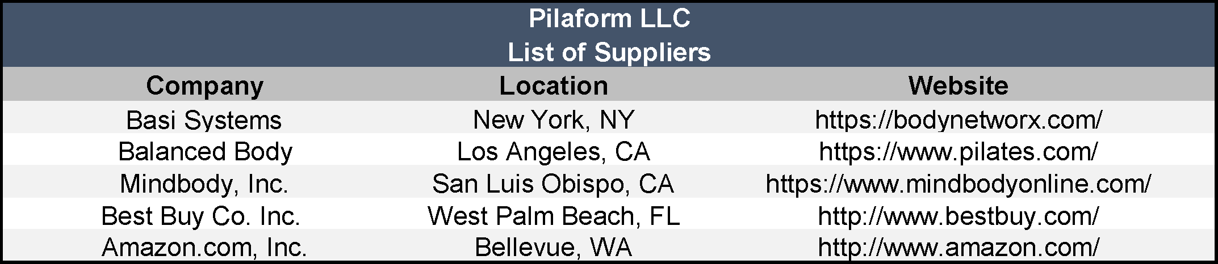

**Job creation**

Furthermore, Pilaform is dedicated to fostering job growth and economic prosperity in the United States. By the conclusion of Year 5, Pilaform’s initiatives are projected to generate eight (8) U.S. jobs. These positions will yield accumulated salaries totaling US$1,027,415, payments to independent contractors amounting to US$269,492, and estimated payroll taxes of US$88,358.

# **7.1 Organizational Chart**

# 

Above graph illustrates the Company’s projected organizational chart for Year 1 through Year 5. Please note that gray-shaded positions represent vendors. Orange-shaded positions represent independent contractors.

# **7.2 Personnel Plan**

By the end of Year 1, the Company’s team will be composed of the following six (6) positions, including two (2) independent contractors:

1. Chief Executive Officer (President)
2. Chief Financial Officer (Secretary and Treasurer)
3. Administrative / Sales Assistant (Part-Time)
4. Pilates Instructor #1
5. Pilates Instructors (Part-Time) #2 (independent contractor)
6. Pilates Instructors (Part-Time) #3 (independent contractor)

By the end of Year 5, the Company plans to increase its staff to reach eight (8) positions, including three (3) independent contractors. Please see the graph below for details.

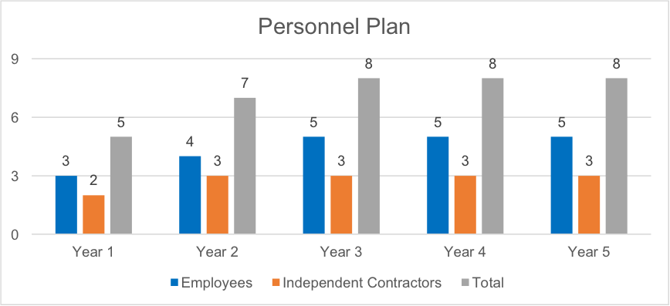

Once an E-2 nonimmigrant visa is approved for Ms. Bartley, she will assume the role of Chief Executive Officer and President of Pilaform. Ms. Bartley boasts eight (8) years of extensive professional experience across various domains.

Her professional experience includes:

* Managerial role at WKD Canada in Ontario, Canada, from 2012 to 2013.
* Independent Contractor providing marketing services to renowned companies such as Brand Momentum, SDI Marketing, Fervent Events Marketing Agency, and GMR Marketing in Ontario, Canada, in 2014.
* ESL teacher at TalktoCanada.com.
* Activity Director at Caressant Care in Ontario, Canada, from 2015 to 2017.
* Regional Lifestyles Manager at Metta Lifestyles in Ontario, Canada, from 2018 to 2019.
* Personal Trainer to private clients from 2021 to 2023.
* Pilates Instructor roles at Neutral Pilates in Ontario, Canada, in 2023 and Imprint Pilates since 2023.

The Company plans to hire the following personnel during Year 1 through Year 5:

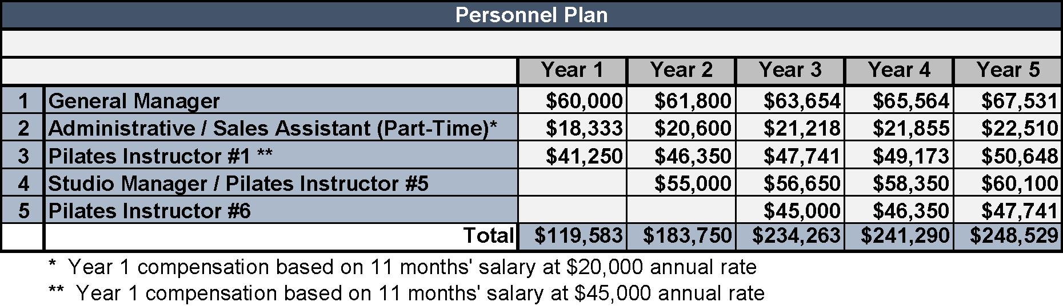

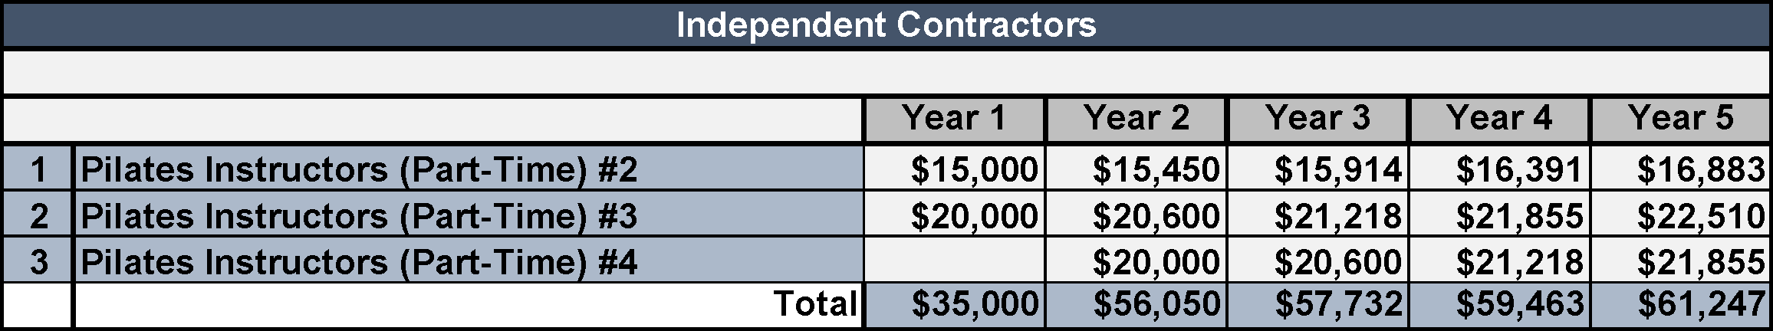

# **7.2 Job Description - Beneficiary**

**Chief Executive Officer**

The Chief Executive Officer (CEO) oversees all aspects of the Company’s operations, including client relations, maintenance, finances, team building, and staff development. The CEO must possess strong communication skills, both verbal and written, and demonstrate outstanding leadership. The CEO must be able to delegate responsibilities, organize complex projects, and establish priorities consistent with Company objectives.

Ms. Bartley will hold the position of CEO. Duties will include:

* Setting Company policies, procedures, standards, specifications, guidelines, and training programs
* Achieving Company objectives in sales, service, quality, appearance of facility, and cleanliness through training of employees and creating a positive, productive working environment
* Defining employment and termination policies
* Hiring, disciplining, overseeing, and firing an Administrative / Sales Assistant and a Team of Pilates Instructors
* Continually striving to develop staff in all areas of managerial and professional development
* Overseeing and ensuring that Company policies on employee performance appraisals are followed and completed on a timely basis
* Developing, planning, and carrying out marketing, advertising, and promotional activities and campaigns
* Making decisions regarding major financial operations of the Company, including financial forecasts and future investments
* Directing the treasury function of the Company, including establishing financial strategies, banking, risk management, and credit arrangements
* Performing financial forecasting and making decisions based on capital budgeting, cash flow analysis, pro forma financial statements, and external financing requirements based on a review of financial analyses of operations for guiding management, including reports that outline the Company’s income, expenses, and earnings
* Directing compliance with Company policies and all applicable local, state, and federal laws
* Analyzing operations to evaluate the performance of the Company’s staff in meeting objectives; and
* Determining areas of potential cost reduction, improvements, or policy change

# **8. Financial Plan**

# **8.1 Revenue Forecast**

The sales forecast yearly summary for the first five years of operations is included in the following chart. These projections are based on the industry in general and the investor’s expansion plans.

***Due to rounding, some totals may not correspond with the multiplication of the separate figures.***

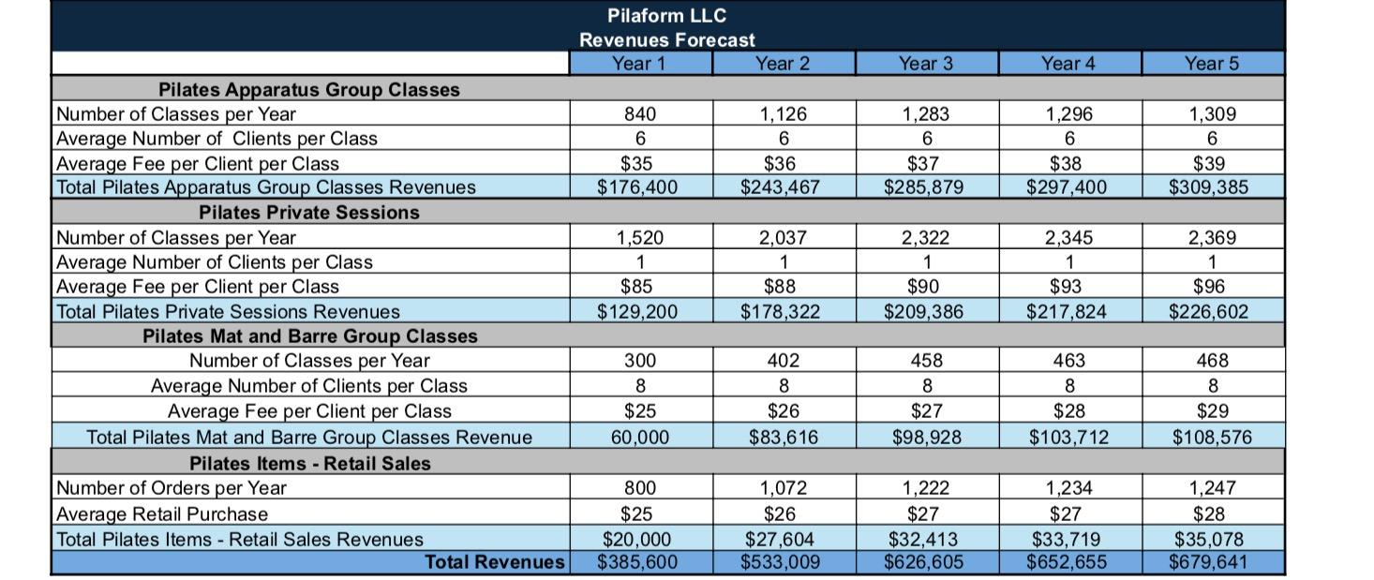

# **8.2 Projected Profit and Loss**

In addition to generating sufficient income to sustain the treaty investor, Ms. Bartley, and her family, her investment will also yield tangible benefits for the local economy through the creation of direct jobs. Furthermore, the business will stimulate indirect job expansion by fostering commerce for various local entities, including CPAs, banks, and independent contractors, among others.

Below is the Company’s pro-forma profit and loss statement for Year 1 through Year 5.

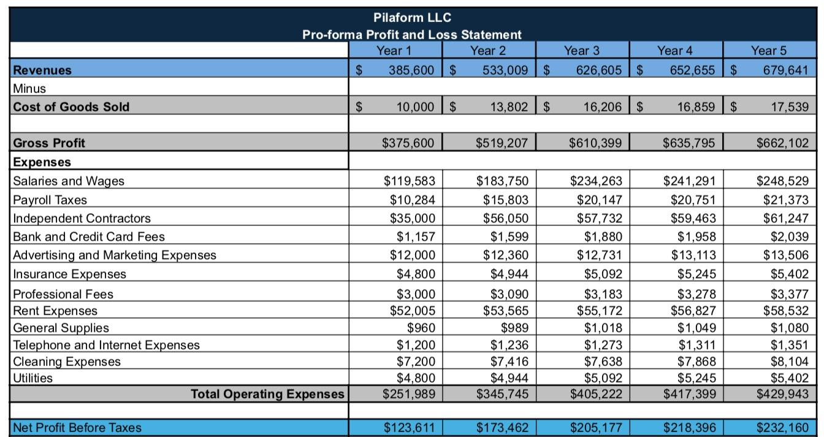

# **8.3 Five-Year Forecast of Investor Income**



1. Polaris Market Research “Pilates & Yoga Studios Market Share, Size, Trends, Industry Analysis Report” | January 2024
2. https://www.pilatesanytime.com/blog/more/pilates-history-who-was-joseph-pilates
3. https://health.clevelandclinic.org/everything-you-want-to-know-about-pilates
4. https://www.basipilates.com/
5. IBISWorld Industry Report “Pilates & Yoga Studios in the US” | December 2023
6. PMA “Pilates in America” | 2016
7. IBISWorld Industry Report “Pilates & Yoga Studios in the US” | December 2023
8. IBISWorld Industry Report “Pilates & Yoga Studios in the US” | December 2023
9. IBISWorld Industry Report “Pilates & Yoga Studios in the US” | December 2023
10. IBISWorld Industry Report “Pilates & Yoga Studios in the US” | December 2023
11. Pilates in America Study | 2016

    A Megaformer machine with a moving platform and springs for resistance that is used for Lagree Method workouts, which involve slow, total-body exercises.
12. https://lftl.basipilates.com/